**Bill of materials**

**Fabrication of a single manipulator**

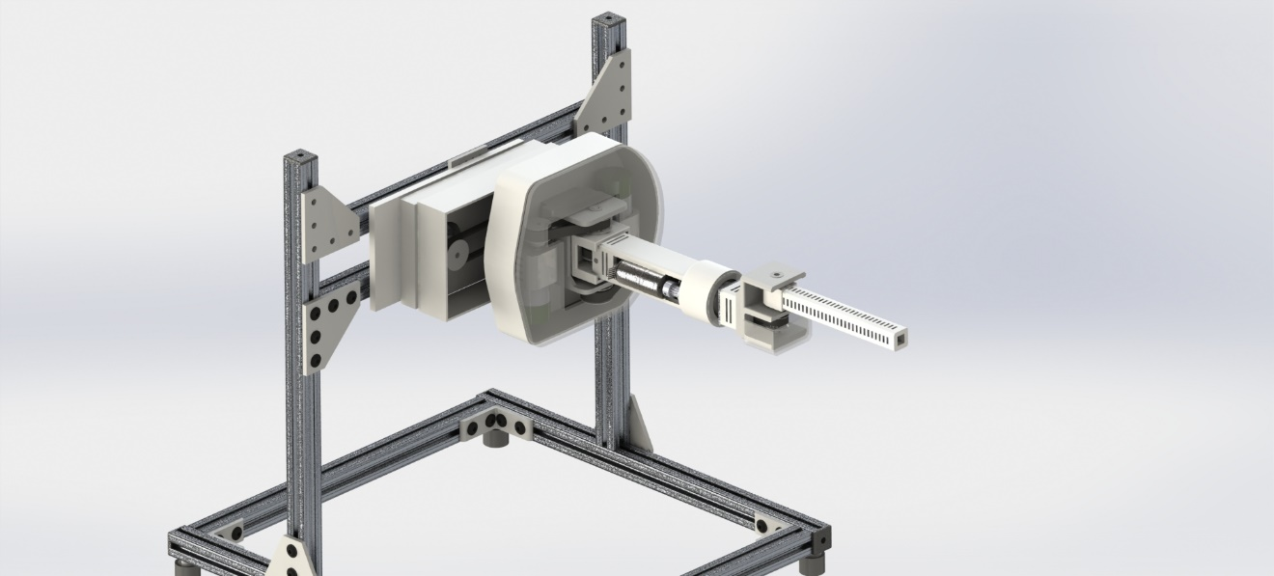

**Figure 1. Tentative CAD drawing of the proposed manipulator**

**Placed orders:**

**For the base joint (with highest**

[**http://www.robotis.us/dynamixel-xm540-w150-r/**](http://www.robotis.us/dynamixel-xm540-w150-r/)

**Quantity: 1**

Operating Voltage : 12V

Stall Torque : 7.3 Nm

No load speed : 53 RPM (318 deg/sec)

Operating modes : Torque control, Position control (0.088 deg resolution, 4096 counts), Velocity Control

Weight: 162g

Communication: RS485

*Maxon BLDC motor actuation*

**Cost ~ $459**

**Required components:**

[**http://www.robotis.us/dynamixel-xm430-w210-r/**](http://www.robotis.us/dynamixel-xm430-w210-r/)

**Quantity: 3**

Operating Voltage : 12V

Stall Torque : 3.0 Nm (Linear interpolation for continuous speeds)

No load speed : 77 RPM (362 deg/sec)

Operating modes : Torque control, Position control (0.088 deg resolution, 4096 counts), Velocity Control

Weight: 82g

Communication: RS485

*BLDC motor actuation (not Maxon)*

**Cost ~ $239 x 3**

**Miscellaneous:**

Robot Cable-4P 100mm 10pcs

**Cost ~ $13**

3D printer material (PLA, approx. 3 reels)

**Cost ~ $20 x 3**

Miscellaneous build materials

e.g.: shaft rods, bearings, and screws

**Cost ~ $50**

Wrist linear motor:

**Cost ~ $20**

**Gripper: Not included (should discuss about it)**